Eperiment 1  
Bilateral liberalisation SSA,EU - tariff and subcidies.

**1.1) Demand**

qfm[**EU] Food Mnfcs Svces CGDS

Food 0.27 0.88 1.32 0.51

Mnfcs -0.91 0.17 0.03 0.00

Svces -1.00 0.09 -0.06 -0.08

qfm[**SSA] Food Mnfcs Svces CGDS

Food -0.11 -9.93 -7.90 -7.28

Mnfcs 15.21 4.10 6.77 5.43

Svces 14.69 2.96 5.49 7.27

**1.2) prices**

pfm[**EU] Food Mnfcs Svces CGDS

Food -0.86 -0.86 -0.86 -0.86

Mnfcs -0.10 -0.10 -0.10 -0.10

Svces -0.05 -0.05 -0.05 -0.05

pfm[**SSA] Food Mnfcs Svces CGDS

Food 8.81 8.81 8.81 8.81

Mnfcs -1.11 -1.11 -1.11 -1.11

Svces -0.36 -0.36 -0.36 -0.36

**1.3) Endowments**

Demand for endowments

qfe[**EU] Food Mnfcs Svces CGDS

Land 0.00 0.95 0.96 0.81

UnskLab -0.97 0.18 0.04 -0.00

SkLab -0.99 0.14 -0.01 -0.03

Capital -0.97 0.18 0.03 -0.01

NatRes -0.00 -0.00 -0.00 -0.00

qfe[**SSA] Food Mnfcs Svces CGDS

Land -0.00 -9.46 -8.56 -6.97

UnskLab 8.36 -5.89 -2.87 -1.16

SkLab 9.78 -3.52 0.11 1.00

Capital 9.64 -3.77 -0.20 0.78

NatRes 0.02 0.00 0.00 0.00

Prices of endowments

pfe[**EU] Food Mnfcs Svces CGDS

Land -1.69 -0.76 -0.75 -0.90

UnskLab -0.10 -0.10 -0.10 -0.10

SkLab -0.06 -0.06 -0.06 -0.06

Capital -0.09 -0.09 -0.09 -0.09

NatRes -1.69 0.06 -0.07 -0.10

pfe[**SSA] Food Mnfcs Svces CGDS

Land 20.30 8.92 10.00 11.92

UnskLab 5.34 5.34 5.34 5.34

SkLab 3.09 3.09 3.09 3.09

Capital 3.31 3.31 3.31 3.31

NatRes 20.26 -0.07 3.16 4.12

**1.4) Imports**

qim SSA EU ROW

Food -5.2806 0.9061 -0.0792

Mnfcs 6.6116 0.0582 -0.0283

Svces 6.5286 -0.0690 -0.0421

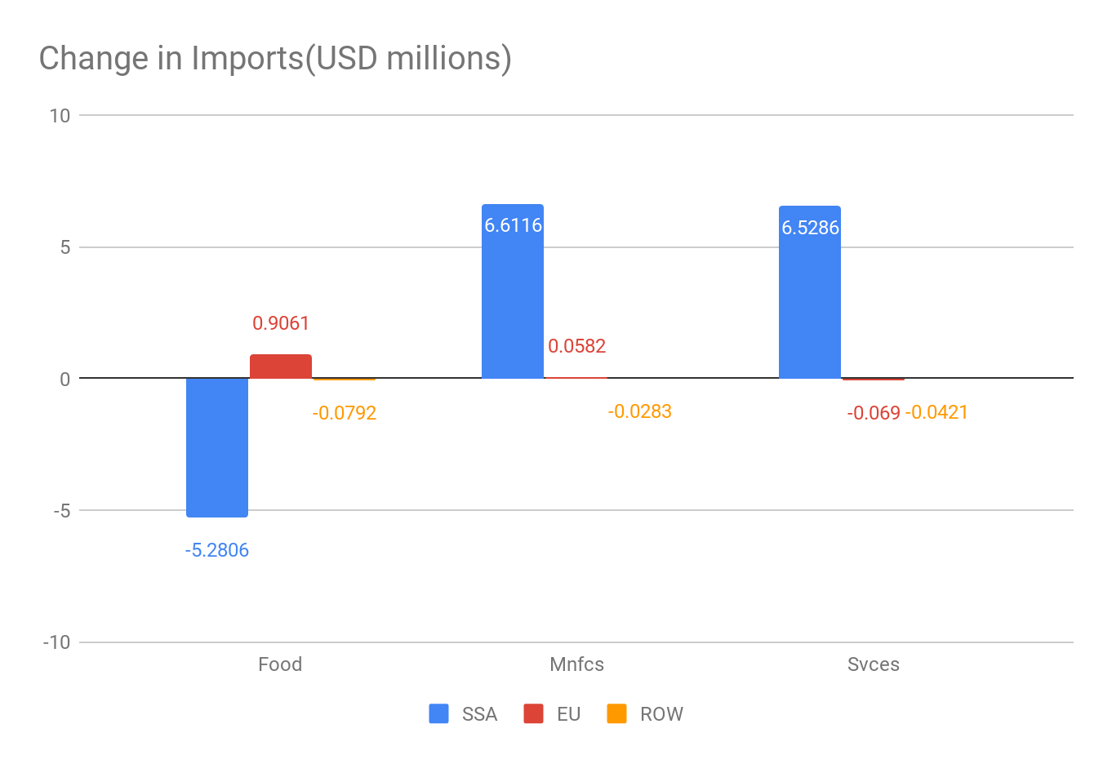

**1.5) Exports**

qxs[*EU*] SSA EU ROW

Food -57.86 -2.09 0.94

Mnfcs 16.49 0.01 0.40

Svces 8.59 0.09 0.28

qxs[*SSA*] SSA EU ROW

Food 14.20 83.26 -18.12

Mnfcs -13.20 13.72 -12.97

Svces -7.25 -7.15 -11.78

1)TOT

Tot (Sim) Pre Post Ch/%Ch

SSA 0.8000 1.0000 1.0080 0.0080

EU -0.0041 1.0000 1.0000 -0.0000

ROW -0.0148 1.0000 0.9999 -0.0001

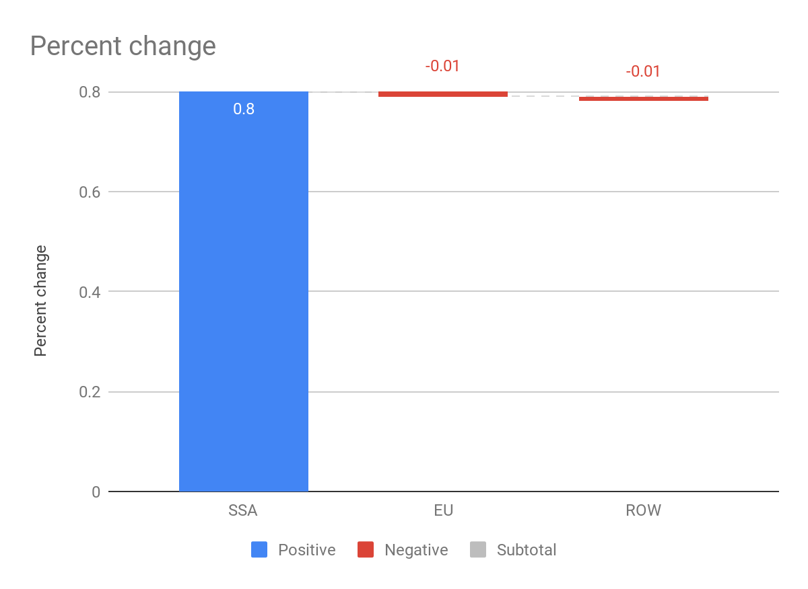

2)Trade Balance

DTBAL (Sim)

SSA 29.3086

EU -60.9765

ROW 31.6680

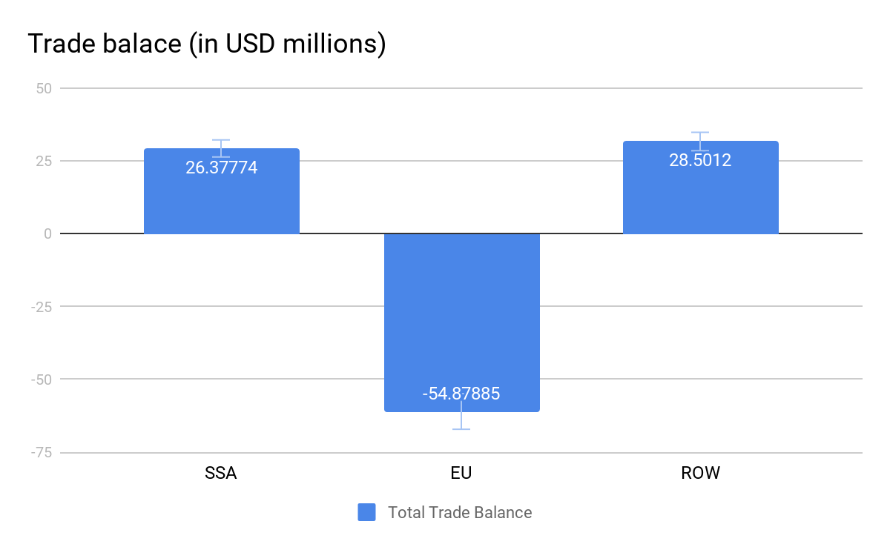

DTBALi SSA EU ROW

Food 6592.2578 -7221.2227 110.3860

Mnfcs -4727.6343 5436.0601 -946.1835

Svces -1835.3147 1724.1863 867.4654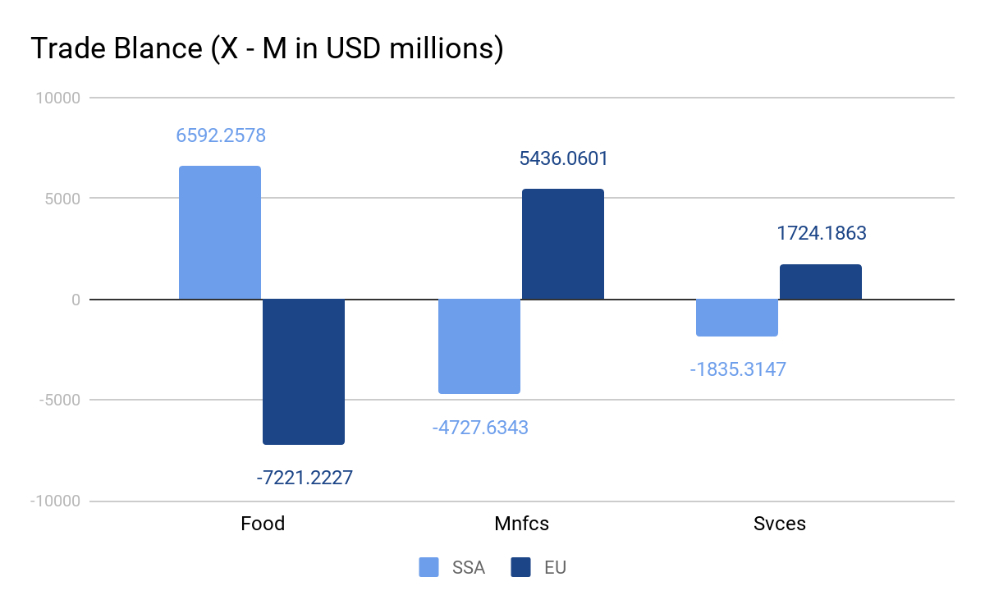

4) exports FOB prices

qxw SSA EU ROW

Food 47.0439 -2.2444 0.0007

Mnfcs -2.4276 0.4276 -0.0634

Svces -8.1638 0.3249 0.1128

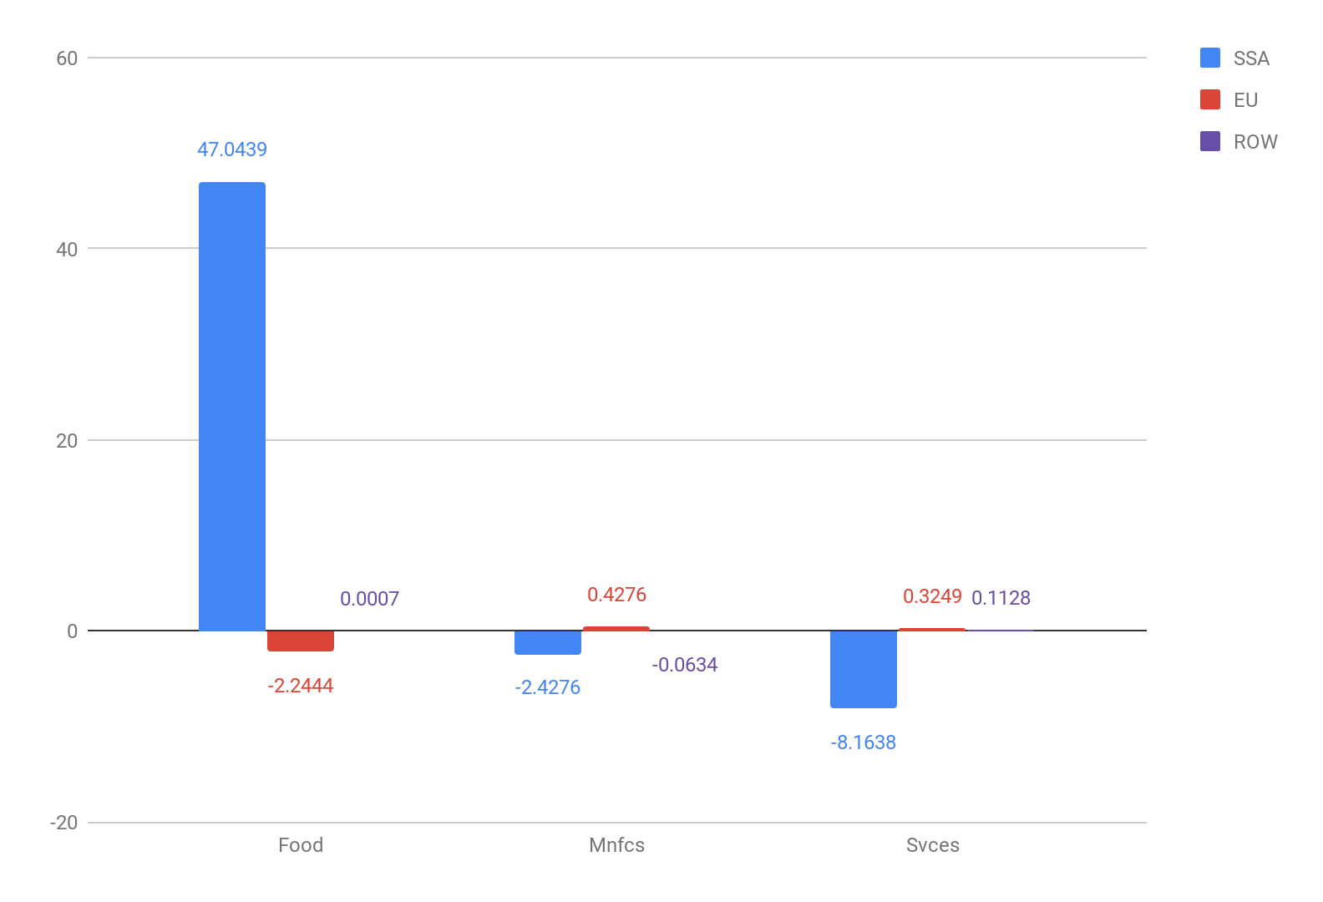

5) change in gdp

vgdp (Sim)

SSA 3.3619

EU -0.1039

ROW -0.0283

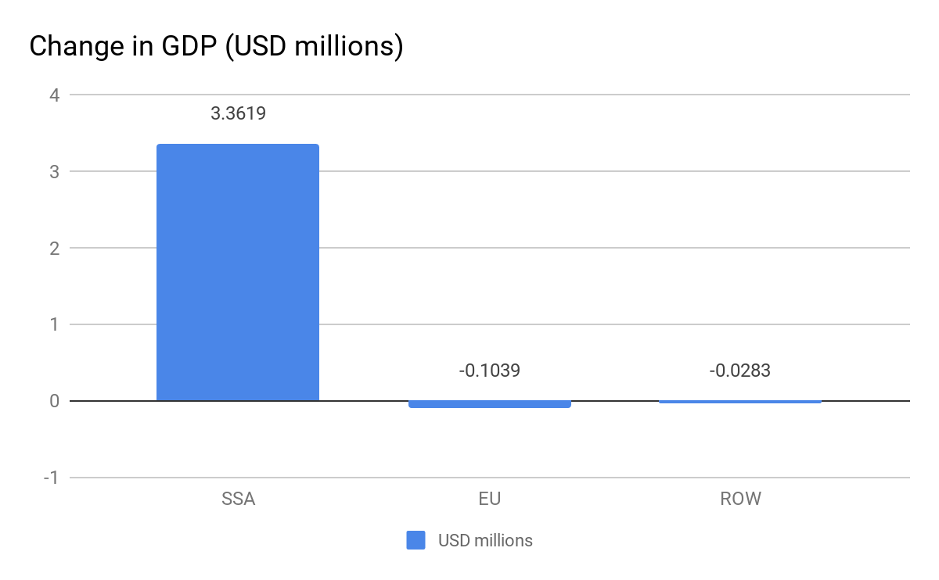

6) Demands of domestic and imported goods.